1. **INTRODUCTION**
   1. **Detailed Problem Definition**

The problem with public auction is that the participation of the public is very limited. The aim of the project is to socialize the auction so that people from far & wide and even across the continent can participate in it. The “Online Auction” site is developed with a vision to wipe out the inherent problems of “Conventional Auction House”. The salient features of the site are as follows:

1. Paperless Auction System
2. It’s accessible to everyone, at any time no matter where they are.
3. Reliable user validation & checking.
4. Easy online settlement.

“Online Auction” is designed in such a way that it is as user friendly as possible. So, any aspiring bidder or seller can visit the site and engage in bidding with least effort.

* 1. **Need for The New System**

The purpose is to develop a user-friendly auctioning site where product can be auctioned and provide value-added services to the bidders and the sellers. Secure registration for all users including a personal profile.

Another purpose for developing this application is to generate the report automatically.

* 1. **Project scope**

Online bids take place at any time, 24/7. In a word, a market that never sleeps. There are literally no geographical boundaries with online auctions.

Items are listed and allowing buyers to research and decide properly before bidding. Once provided an internet access, sellers and bidders can take part at the auction from everywhere.

* 1. **System Overview**

The key features required in the system are as follows:

* **Bidder Login:** Here the buyer or the product bidder can see a list of products up for bidding and place his/her bid on the product.
* **Seller Login:** This is the seller module where the seller posts a product up for auctions.
* **Admin Login:** This module is for the administrator who may delete fake or unwanted ads.
* **Report generation:** Admin gets a report whenever wanted to state various products up for bidding and various users registered on the website.
  1. **Hardware And Software Specification**

1. **Software Requirement:**

* Technology: Python Django
* IDE: PyCharm/Atom
* Client-Side Technologies: HTML, CSS, JavaScript, Bootstrap
* Server-Side Technologies: Python
* Data Base Server: SQLite
* Operating System: Microsoft Windows/Linux

1. **Hardware Requirement:**

* Processor: Pentium-III (or) Higher
* Ram: 64MB (or) Higher
* Hard disk: 80GB (or) Higher

**2. ANALYSIS**

**2.1 Feasibility Study**

Feasibility study is the important test of the system proposed according to its work, ability to meet the user needs & effective use of the resources.

The following points have been considered while studying the feasibility of the proposed system.

1. Technical feasibility.
2. Operational feasibility.
3. Economical feasibility.

**2.1.1 Technical Feasibility**

Technical feasibility is complete study of project in terms inputs, outputs fields’ processor, program, procedures, etc. It is the process of accessing the development application ability to construct a proposed system. The technical feasibility Online Auction System uses python. It is easy to work and widely used for developing commercial application. It requires programming on Java which will be easy to handle. Software requires minimum hardware configuration which almost all computers possess.

**2.1.2 Operational Feasibility**

The proposed computerized system solves almost most of the major problems as faced by the existing system. The system is designed in such a way that it is easy to operate.

* User support
* No major training and new skills required
* It will help in time saving and task processing
* User will become skilled automatically to using it gradually
* The help menu will help user for different availability in editor

**2.1.3 Economical Feasibility**

The economical feasibility of system is mainly concerned with the means of cost benefit analysis. The proposed system is economical feasible because the cost involves in purchasing the hardware and software are within approachable. The less time involve help in economic feasibility.

**3.DESIGN**

**3.1 Block diagram**

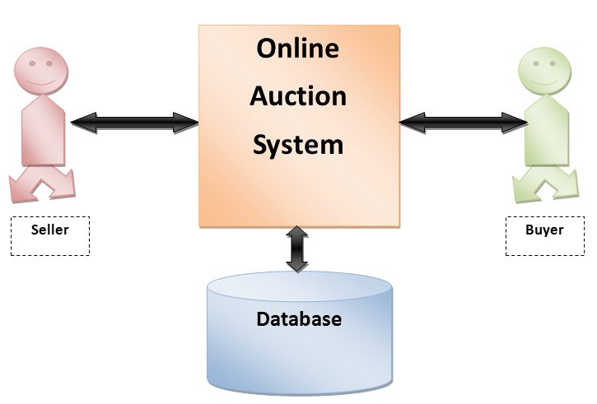

**3.2 Input and Output Screen and Reports**

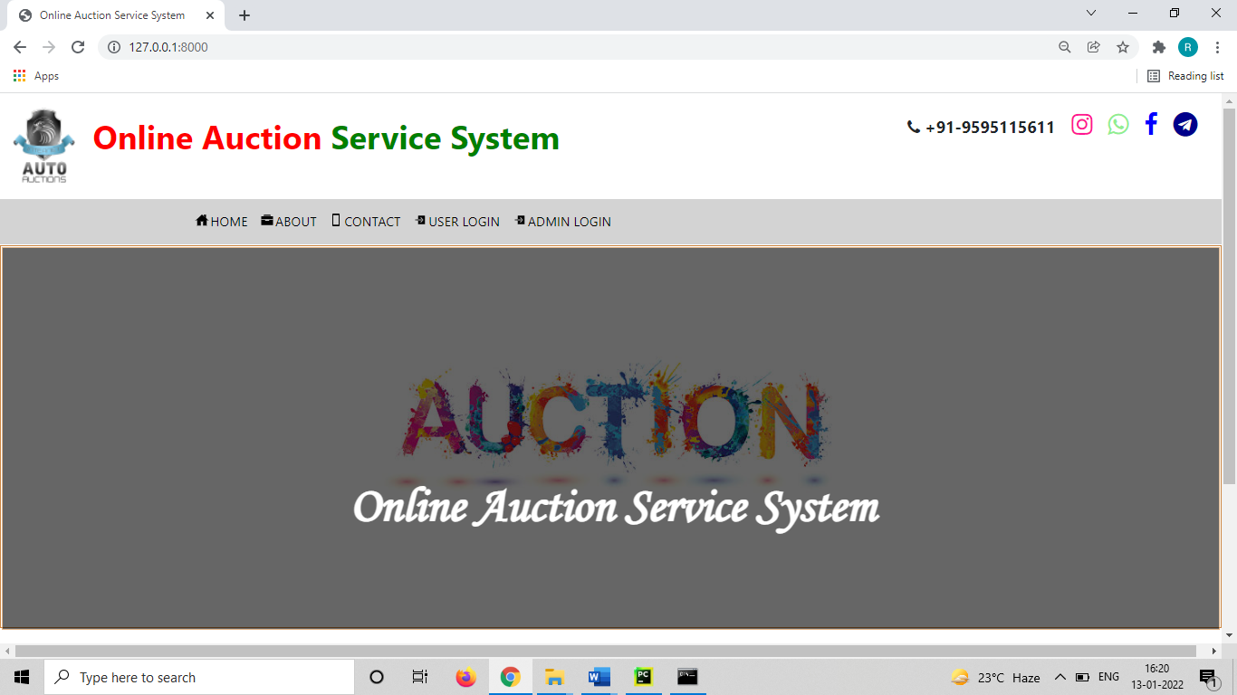

**Home Page**

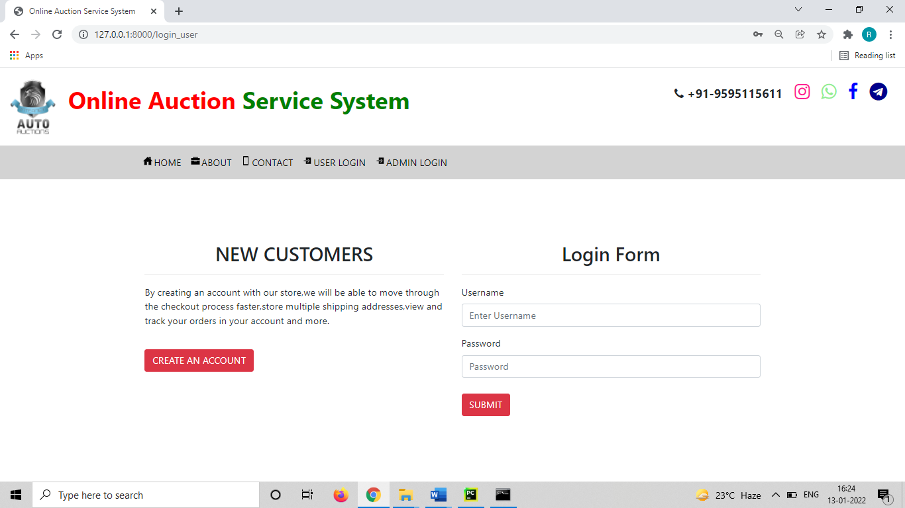

**Login Page**

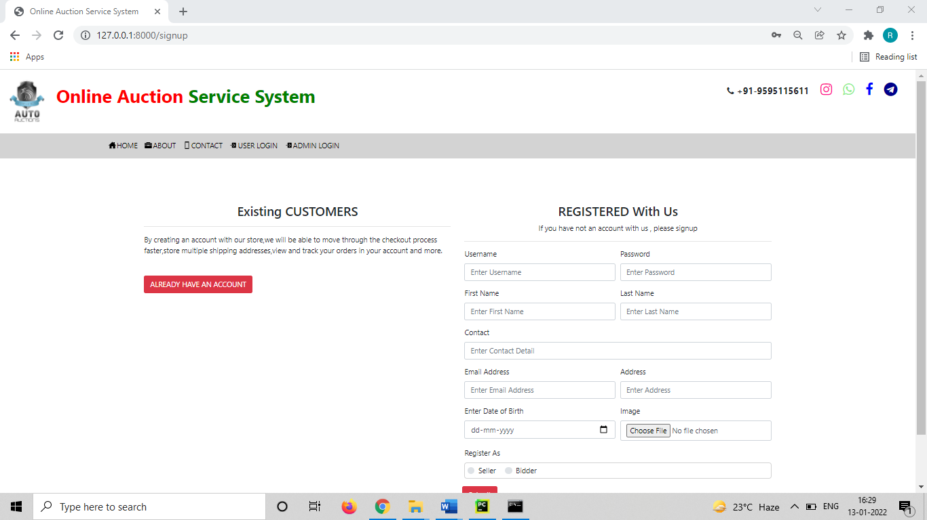

**Registration Page**

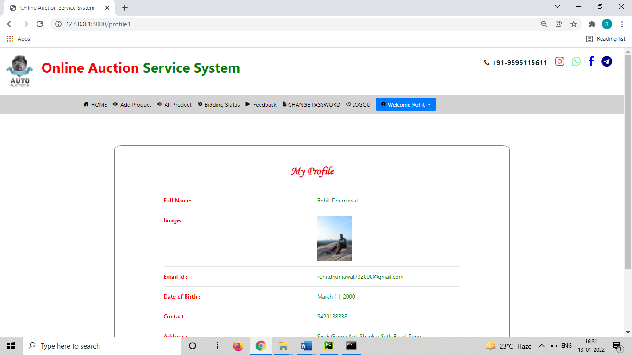

**Seller Home Page**

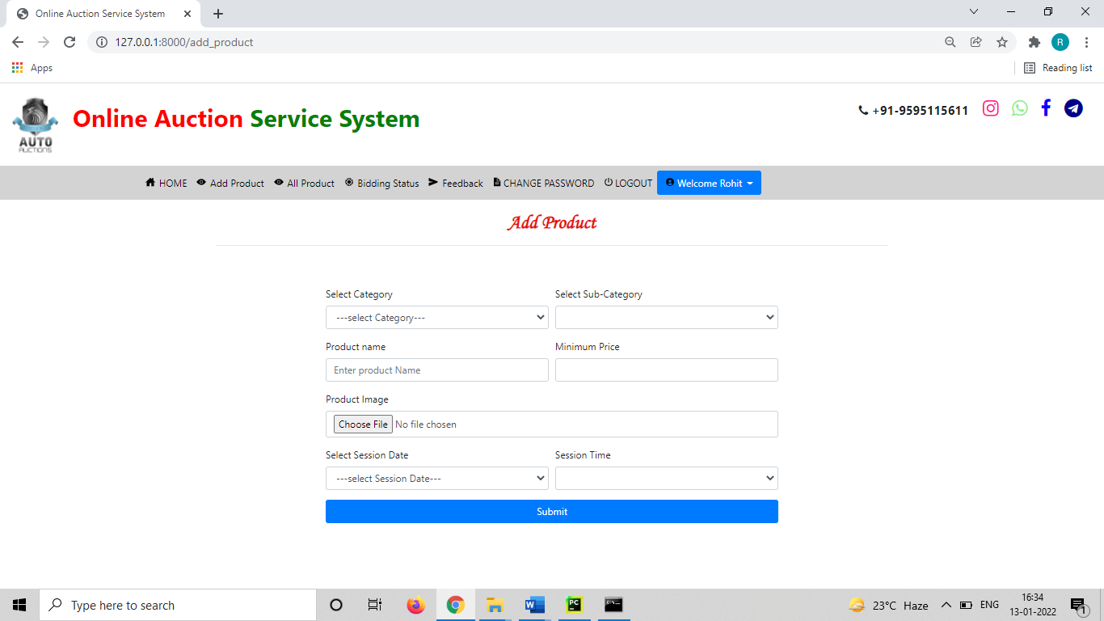

**Add Product for Auction**

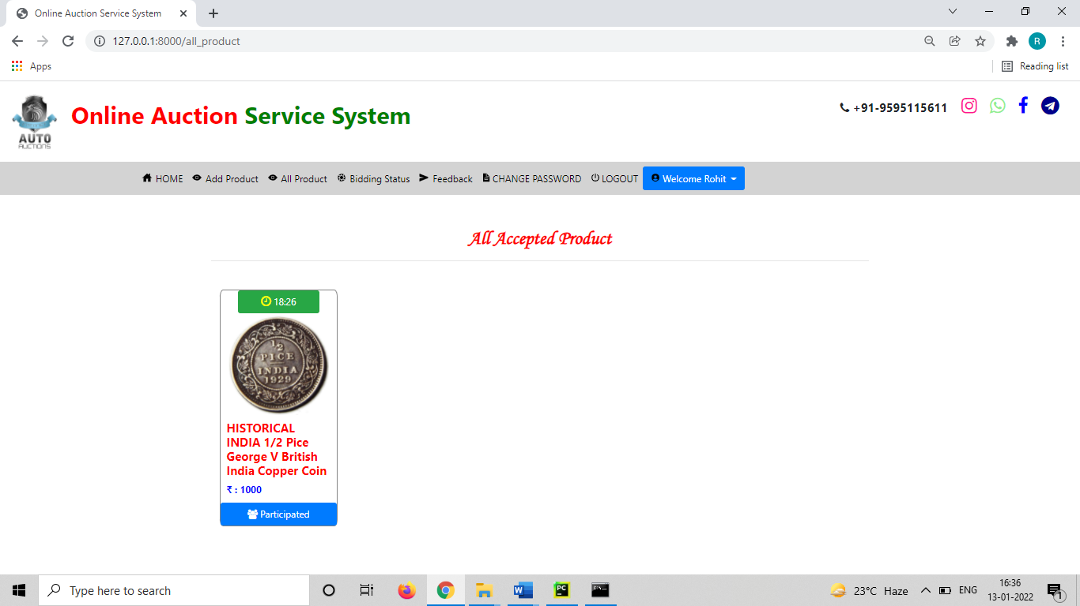

**View Auction Product Page**

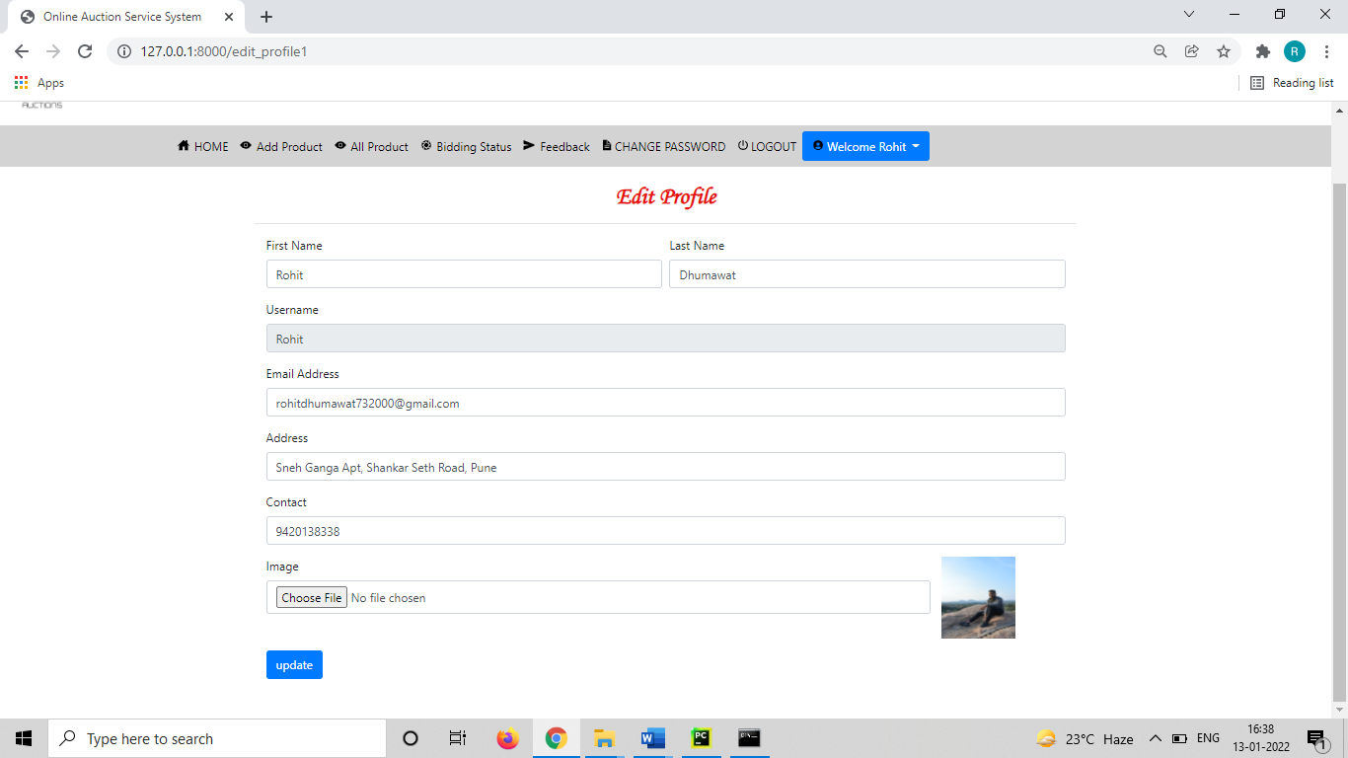

**Edit Profile Page**

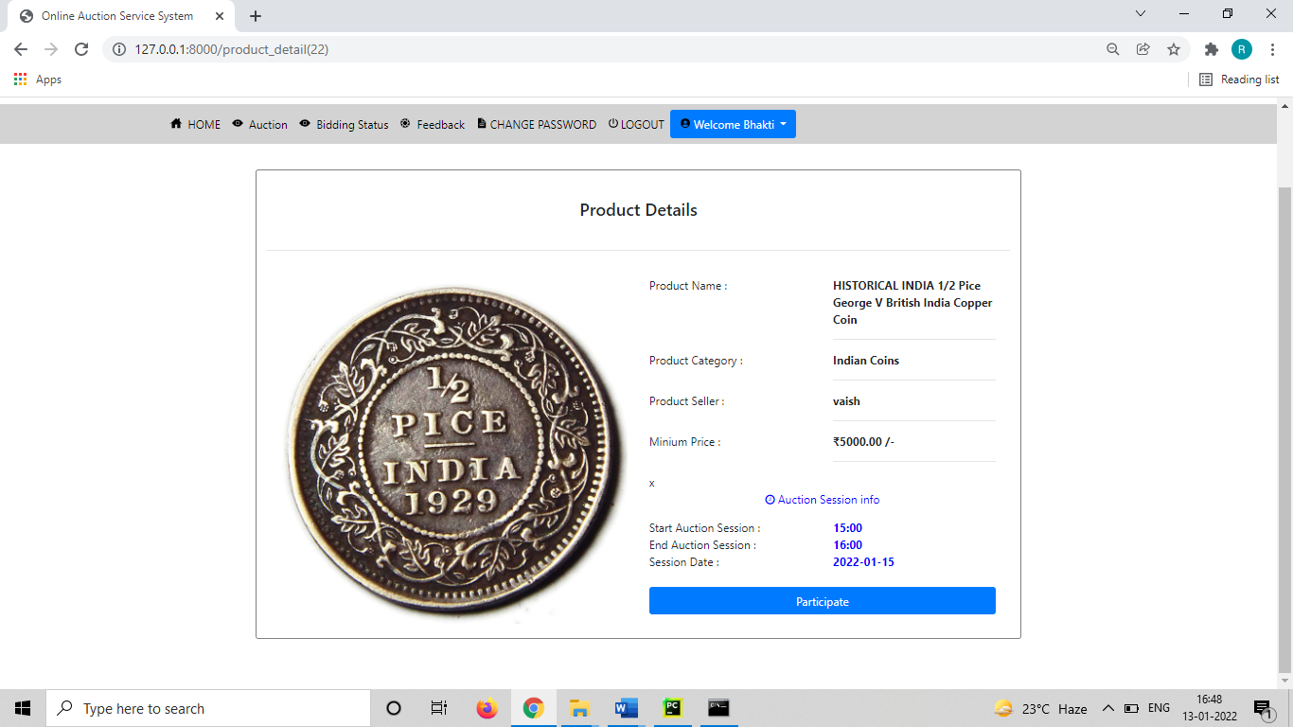

**Auction Product Detail Page**

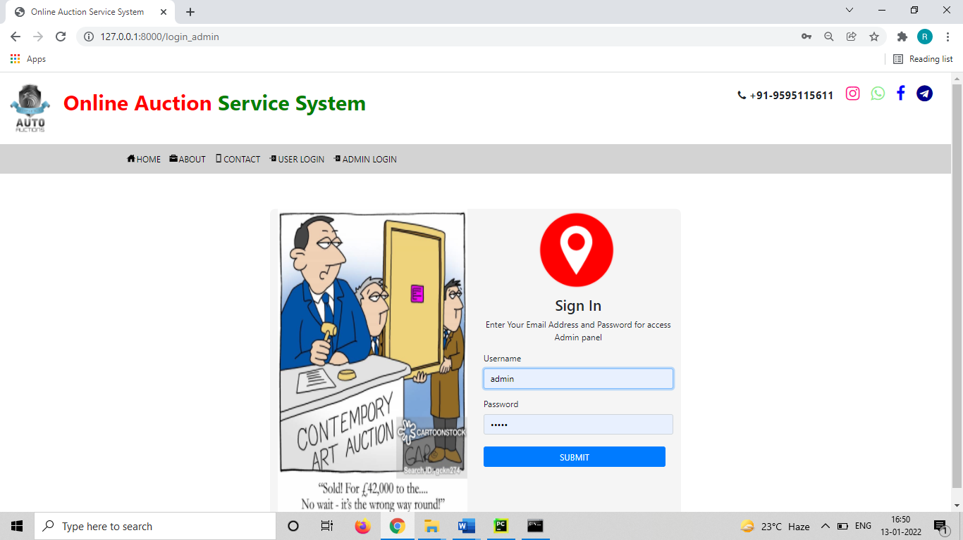

**Admin Login Page**

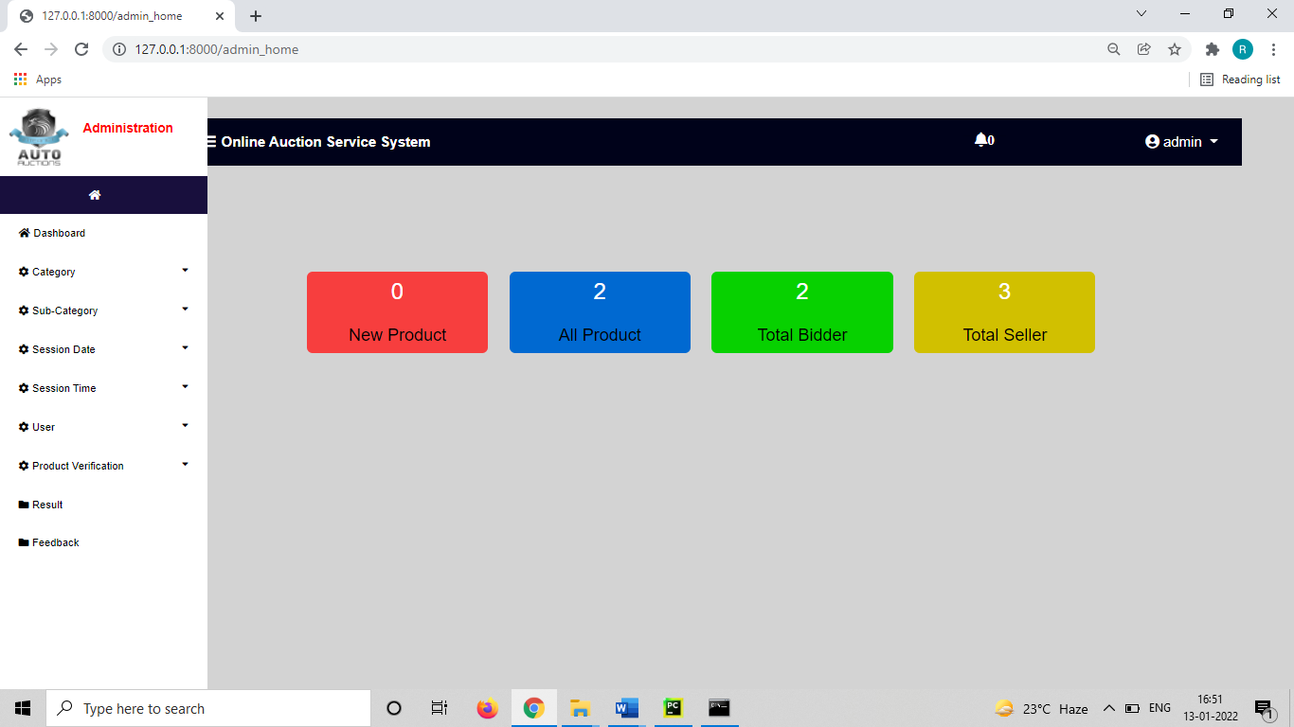

**Auction Home Page**

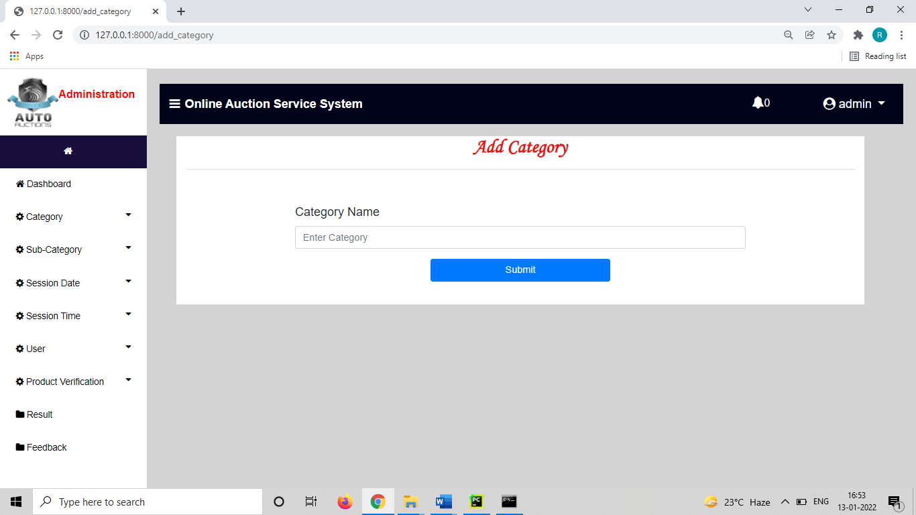

**Add Category Page**

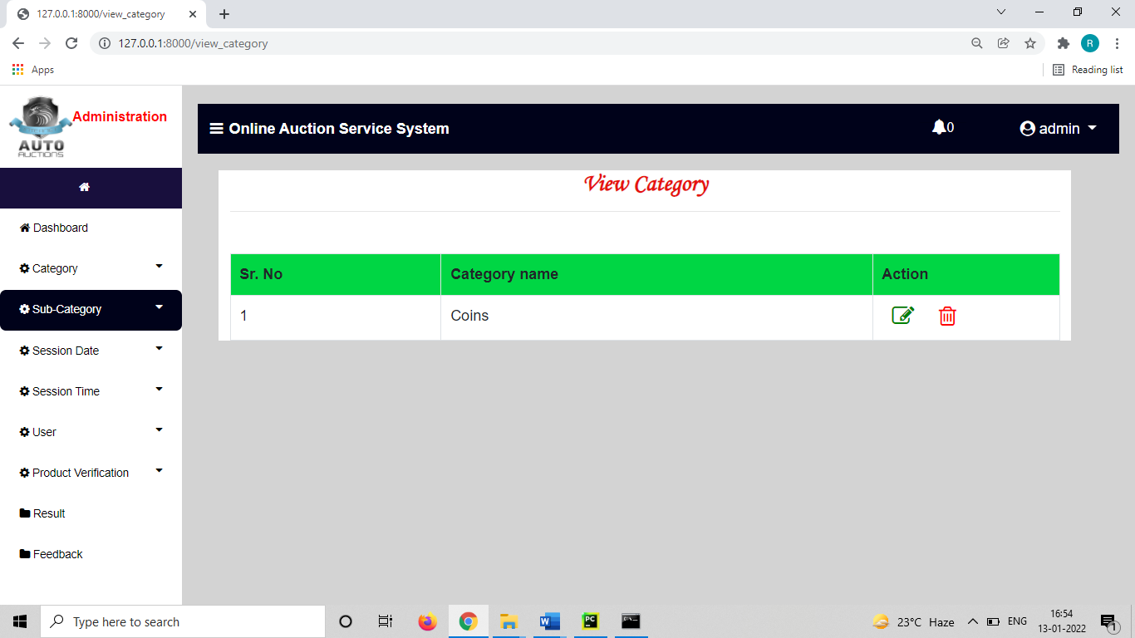

**View Category Page**

**4. UML**

* 1. **Use case Diagram**

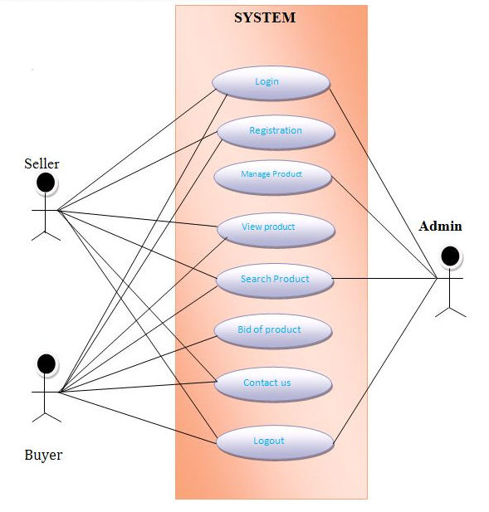

* 1. **Activity Diagram Admin**

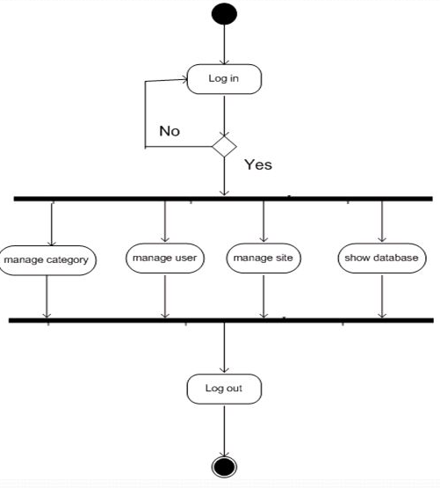

* 1. **Activity Diagram Buyer**

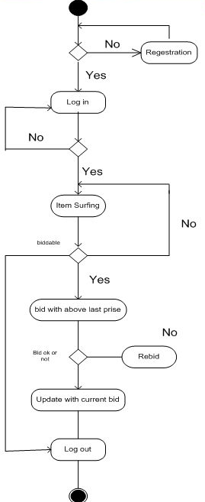

* 1. **Activity Diagram Seller**

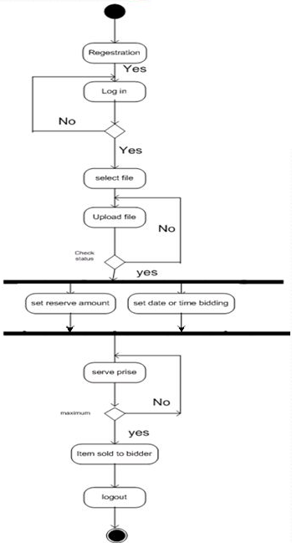

* 1. **DFD Level First**

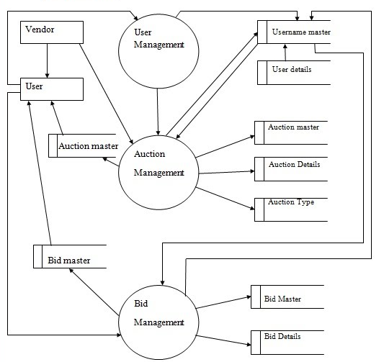

* 1. **DFD Level Second**

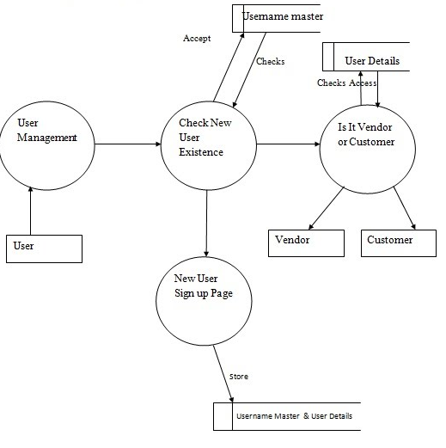

* 1. **ER Diagram**

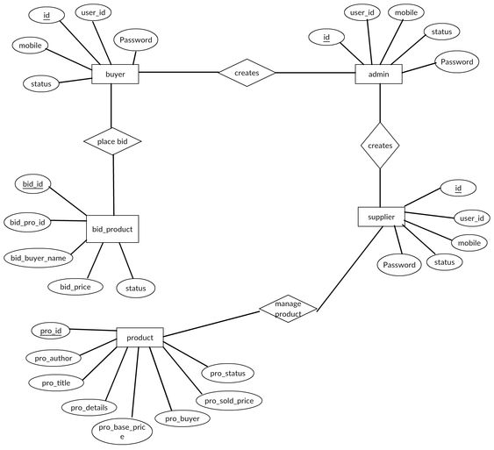

* 1. **Sequence Diagram**

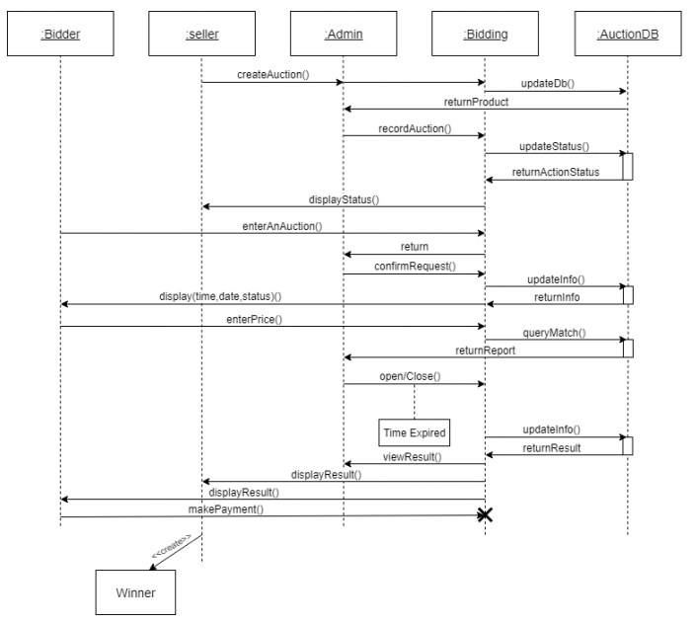

**5. CODING**

**5.1 Programming Languages Used:**

Given below are some of the web technologies used for developing the website.

* **Python**

Python is a widely used general-purpose, high level programming language. It was initially designed by Guido van Rossum in 1991 and developed by Python Software Foundation. It was mainly developed for emphasis on code readability, and its syntax allows programmers to express concepts in fewer lines of code.

Python is a programming language that lets you work quickly and integrate systems more efficiently.

Python is dynamically typed, and garbage collected. It supports multiple programming paradigms, including procedural, object-oriented, and functional programming. Python is often described as a "batteries included" language due to its comprehensive standard library.

* **HTML**

HTML (Hypertext Markup Language) is the set of markup symbols or codes inserted in a file intended for display on a World Wide Web browser page. The markup tells the Web browser how to display a Web page's words and images for the user. Each individual markup code is referred to as an element (but many people also refer to it as a tag). Some elements come in pairs that indicate when some display effect is to begin and when it is to end.

* **Cascading Style Sheet (CSS)**

Cascading Style Sheets (CSS) are a collection of rules we use to define and modify web pages. CSS are like styles in Word. CSS allow Web designers to have much more control over their pages look and layout. For instance, you could create a style that defines the body text to be Verdana, 10 points. Later, you may easily change the body text to Times New Roman, 12 points by just changing the rule in the CSS. Instead of having to change the font on each page of your website, all you need to do is redefine the style on the style sheet, and it will instantly change on all the pages that the style sheet has been applied to. With HTML styles, the font change would be applied to each instance of that font and must be changed in each spot.

CSS can control the placement of text and objects on your pages as well as the look of those objects.

HTML information creates the objects (or gives objects meaning), but styles describe how the objects should appear. The HTML gives your page structure, while the CSS creates the “presentation”. An external CSS is just a text file with a .css extension. These files can be created with Dreamweaver, a CSS editor, or even Notepad.

The best practice is to design your web page on paper first so you know where you will want to use styles on your page. Then you can create the styles and apply them to your page.

* **JavaScript**

JavaScript is a programming language commonly used in web development. It was originally developed by Netscape to add dynamic and interactive elements to websites. While JavaScript is influenced by Java, the syntax is more like C and is based on ECMAScript, a scripting language developed by Sun Microsystems.

JavaScript is a client-side scripting language, which means the source code is processed by the client's web browser rather than on the web server. This means JavaScript functions can run after a webpage has loaded without COMMUNICATING with the server. For example, a JavaScript function may check a web form before it is submitted to make sure all the required fields have been filled out. The JavaScript code can produce an error message before any information is transmitted to the server.

Like server-side scripting languages, such as PHP and ASP, JavaScript code can be inserted anywhere within the HTML of a webpage. However, only the output of server-side code is displayed in the HTML, while JavaScript code remains fully visible in the source of the webpage. It can also be referenced in a separate .JS file, which may also be viewed in a browser.

* **Django**

Django is a web application framework written in Python programming language. It is based on MVT (Model View Template) design pattern. The Django is very demanding due to its rapid development feature. It takes less time to build application after collecting client requirement. This framework uses a famous tag line: **The web framework for perfectionists with deadlines.**

**6. Implementation and System Testing**

After all phases have been perfectly done, the system will be implemented to the server and the system can be used.

* 1. **System Testing**

The goal of the system testing process was to determine all faults in our project. The program was subjected to a set of test inputs and many explanations were made and based on these explanations it will be decided whether the program behaves as expected or not. Our Project went through two levels of testing

* 1. **Unit Testing**

Unit testing is commenced when a unit has been created and effectively reviewed. To test a single module, we need to provide a complete environment i.e., besides the section we would require

* The procedures belonging to other units that the unit under test calls
* Nonlocal data structures that module accesses
* A procedure to call the functions of the unit under test with appropriate parameters
* **Test for the admin module**

**Testing admin login form**

This form is used for logging in of administrator of the system. In this form we enter the username and password if both are correct administration page will open otherwise if any of data is wrong it will get redirected back to the login page and again ask the details.

**Report Generation**

admin can generate report from the main database.

* 1. **Integration Testing**

In the Integration testing we test various combination of the project module by providing the input.

The primary objective is to test the module interfaces to confirm that no errors are occurring when one module invokes the other module.

**7. LIMITATION AND FUTURE ENCHANCEMENTS**

Besides the above achievements and the successful completion of the project, we still feel the project has some limitations, listed as below:

* It is not a large-scale system.
* Only limited information provided by this system.
* Since it is an online project, user needs internet connection to access this software.
* People who are not familiar with computers can’t use this software.

Thisweb application involves almost all the basic features of the online auction system. The future implementation will be online help for the users and chatting with website administrator and enhance the payment and delivery system.

**8. CONCLUSION**

The project entitled “Online Auction System” is developed using HTML, CSS and Bootstrap as front end and Python Django and SQLite database in back end to computerize the process of auction i.e., selling and buying product. This project covers only the basic features required.

Online Auction System will give new approach and dimension to auction system.

It will encourage both buyers and sellers to participate in auction process. Remove geographical boundaries, location constraint and time constraint.